CCR DIGITAL SCREEN POSTING REQUEST
Send to nciccrofficeofcommun@mail.nih.gov

Submitter Name:

Date/time to post slide (please allow 2 business days after submitting this form for the slide to publish):

Date/time to take down slide:

Slide Title:

Slide Content (2 short sentences maximum):

Slide Example:
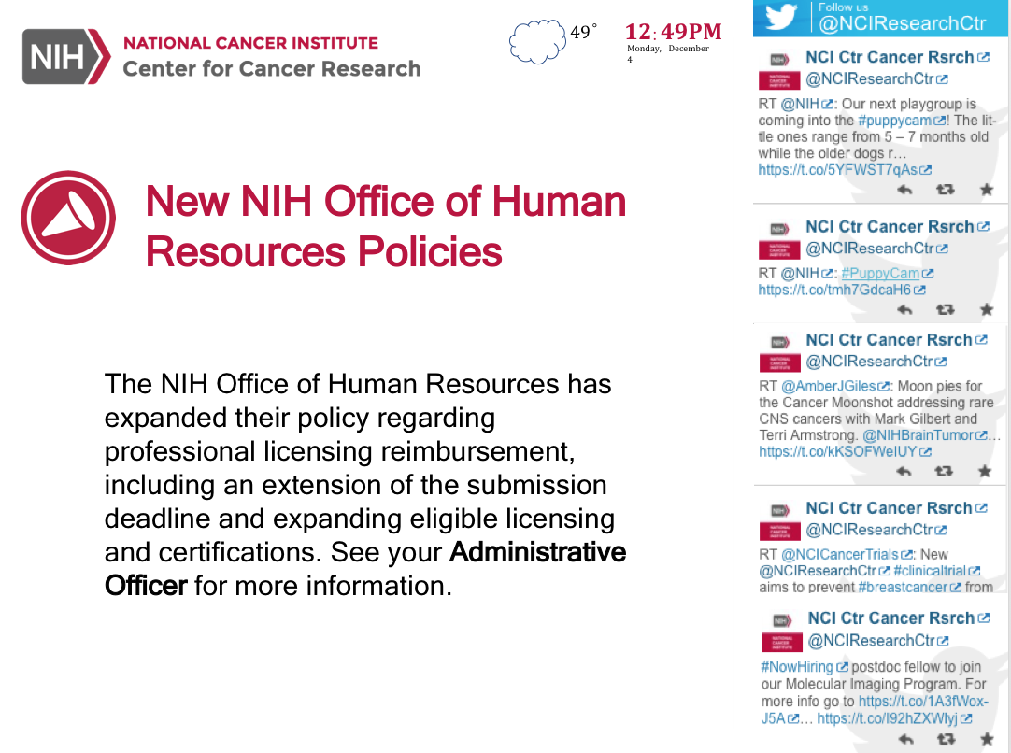

*We will edit your content if needed to fit the slides.*

